1. What are three conclusions we can make about Kickstarter campaigns given the provided data?
   1. Conclusion #1

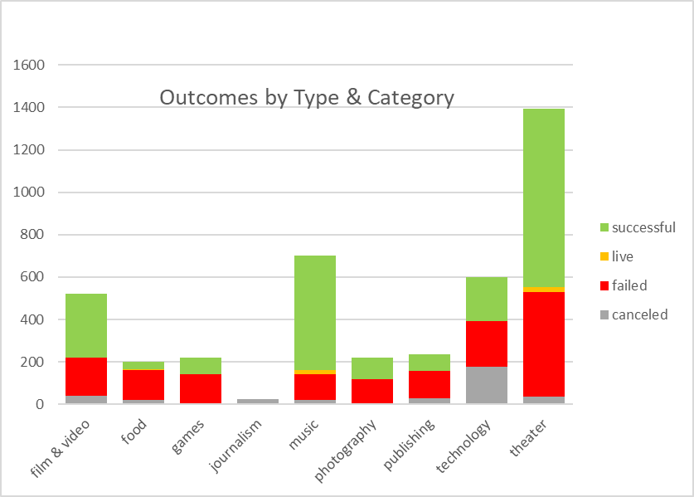

* 1. Conclusion #2

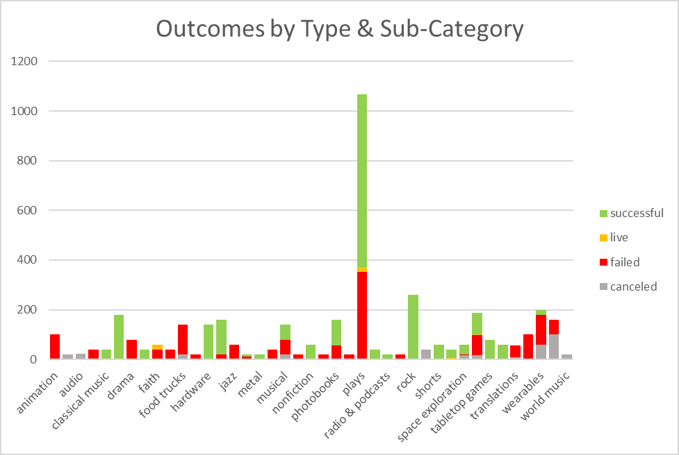

* 1. Conclusion #3

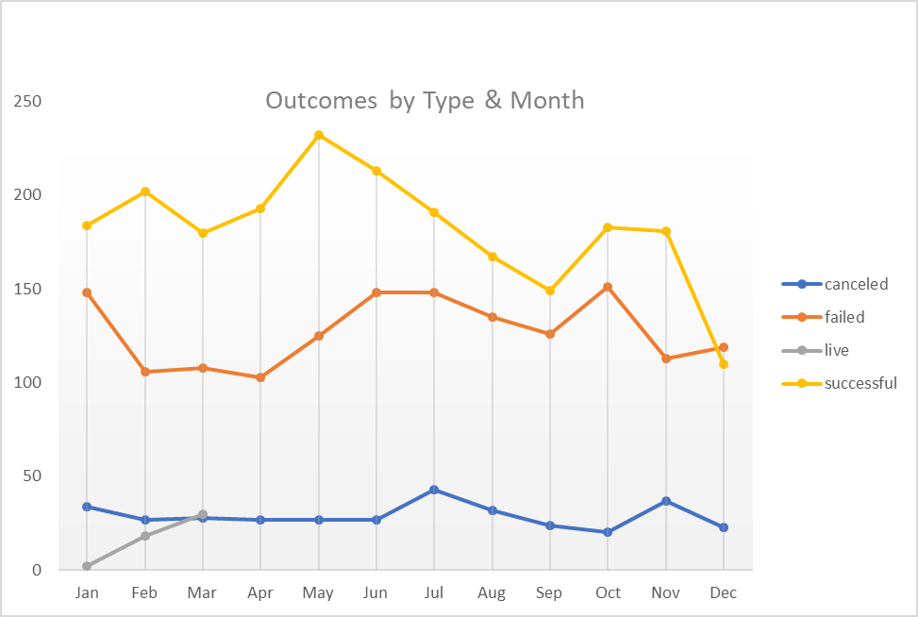



1. What are some of the limitations of this dataset?
   1. No information on backers (repeat backers versus first time/could reveal pertinent trends)
   2. Geographic variable at country level
   3. Link other backer data from additional sources to provide a more robust picture of backers in order to
2. What are some other possible tables/graphs that we could create?
   1. KickStarter’s mission surrounds making the project dreams come true through their crowdfunding platform. Examining the characteristics associated with successfully funded projects would be a helpful addition. KickStarter has an interest in increasing the proportion of projects that are successfully funded (defined as 100% or greater pledged amount of the project goal). Which data variables in the dataset are related to a successful outcome? Are they statistically significant? At what level of statistical significance? Examine funding status as the dependent variable and all those as potential independent variables.
   2. According to Investopedia (insert url), KickStarter’s business revenue is 5% of all funds pledged by backers, regardless if the project was successful funded in full or only funded partially. With this in mind, examining the characteristics of the top quartile of projects that generated the most revenue for KickStarter.
   3. What effect does the staff spotlight have on the status outcome, number of backers, average amount pledged per backer and
   4. How to identify early “at-risk” projects